**Setting up Jenkins to get the code from github and compile**

**Select New Item**



**Enter the project name and select Freestyle Project and Click on “OK”**

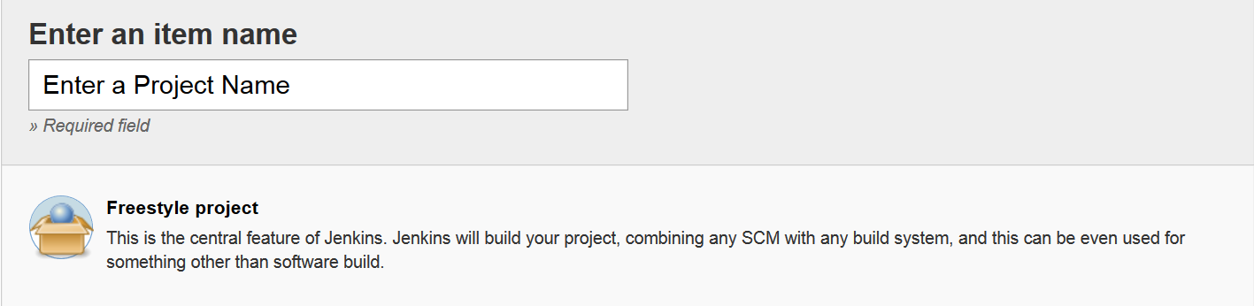

**Select “Git” and Give your repo URL**

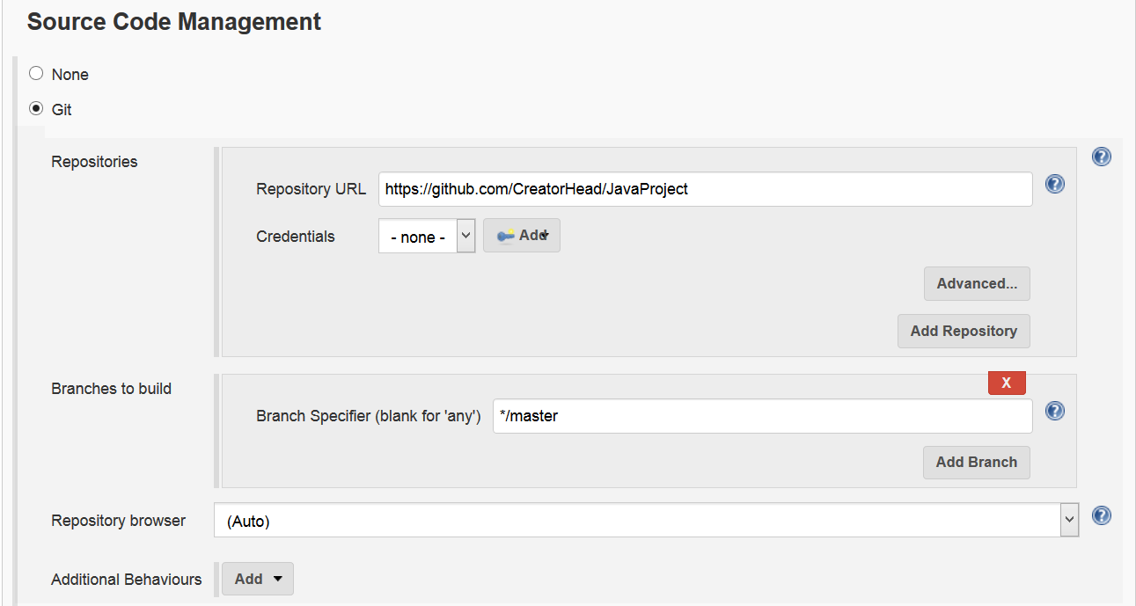

**Go to Build and Select “Invoke top-level Maven targets”**

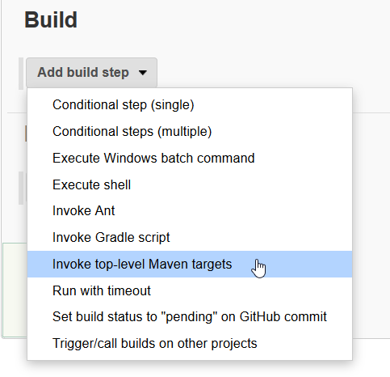

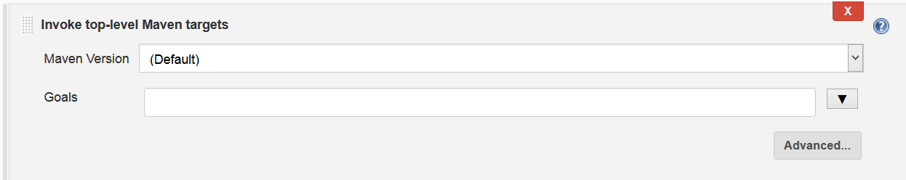

**Select the Inbuilt maven inside Jenkins and in goals write “compile” command and after that click on apply and save.**

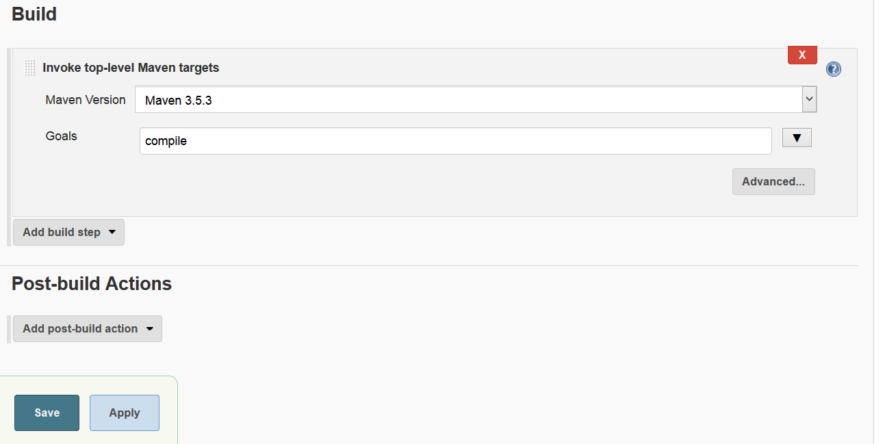

**After Saving the Project click on “Build Now”.**